**CHR Regional Office 3**

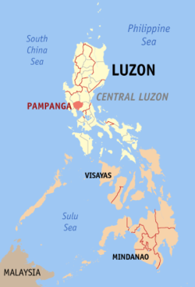Address : *Diosdado Macapagal Government Center*

*Brgy. Maimpis, City of San Fernando*

*Pampanga*

Lot Area : *1,600.00 sq.m.*

Floor Area : *753,4739 sq.m (2-storey building)*

Amount : *Php14,000,000.00*

Date Started : *October 28, 2015*

Date Completed : *April 2016*

*Date Inaugurated : May 17, 2016*

***The newly built CHR Region 3 Office Building:***

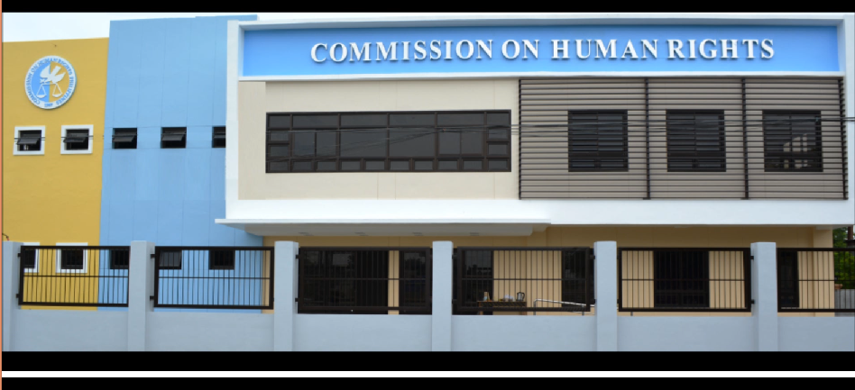

***Inauguration:***

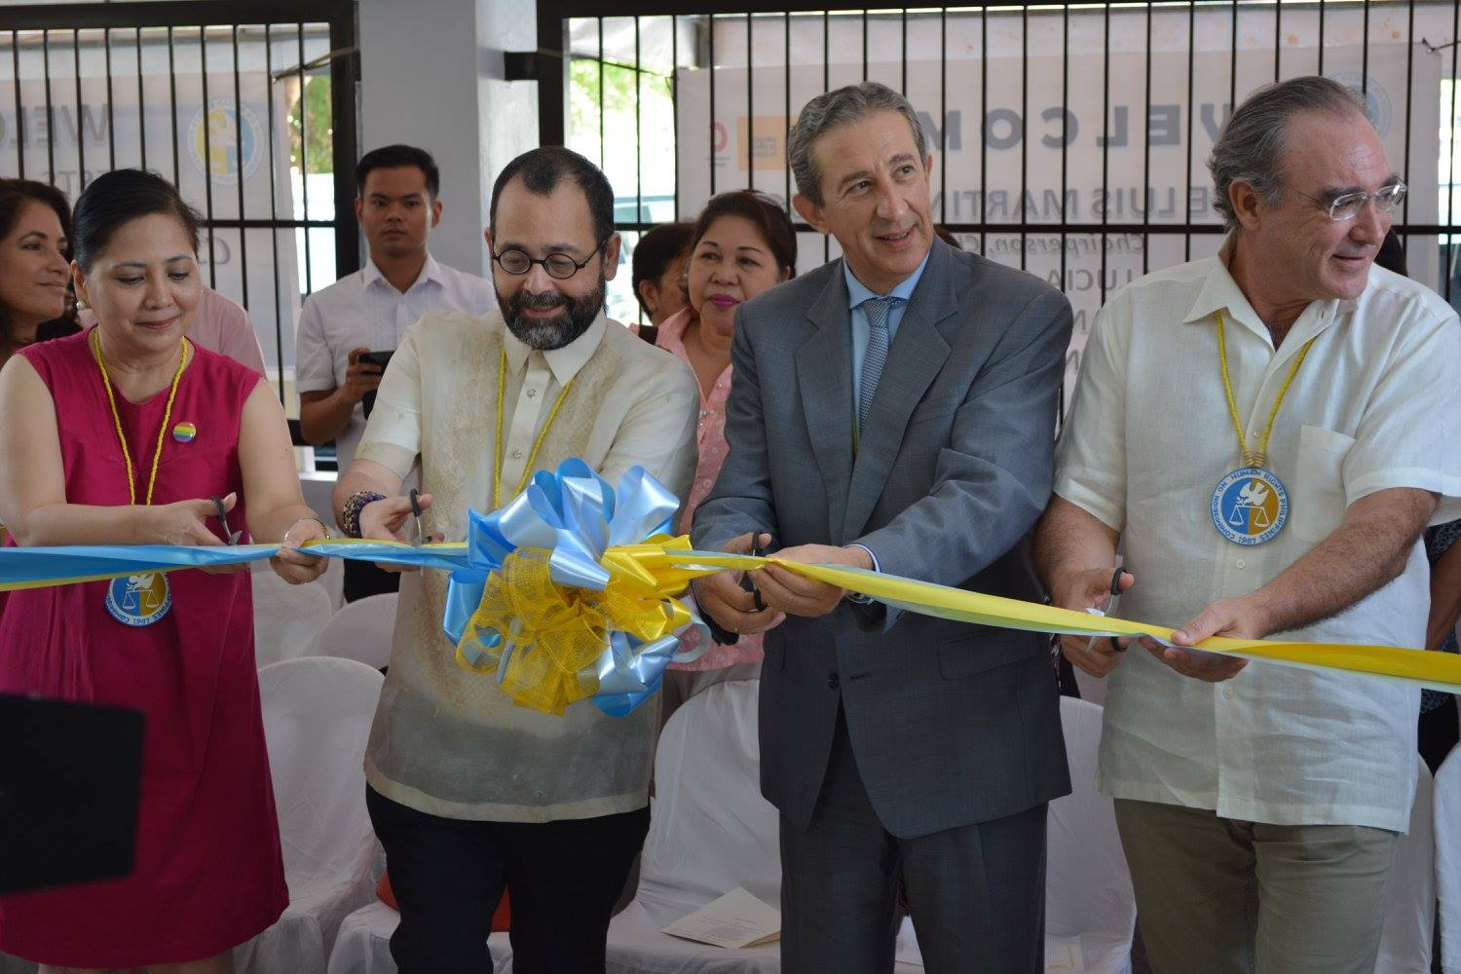

***Groundbreaking Ceremony:***

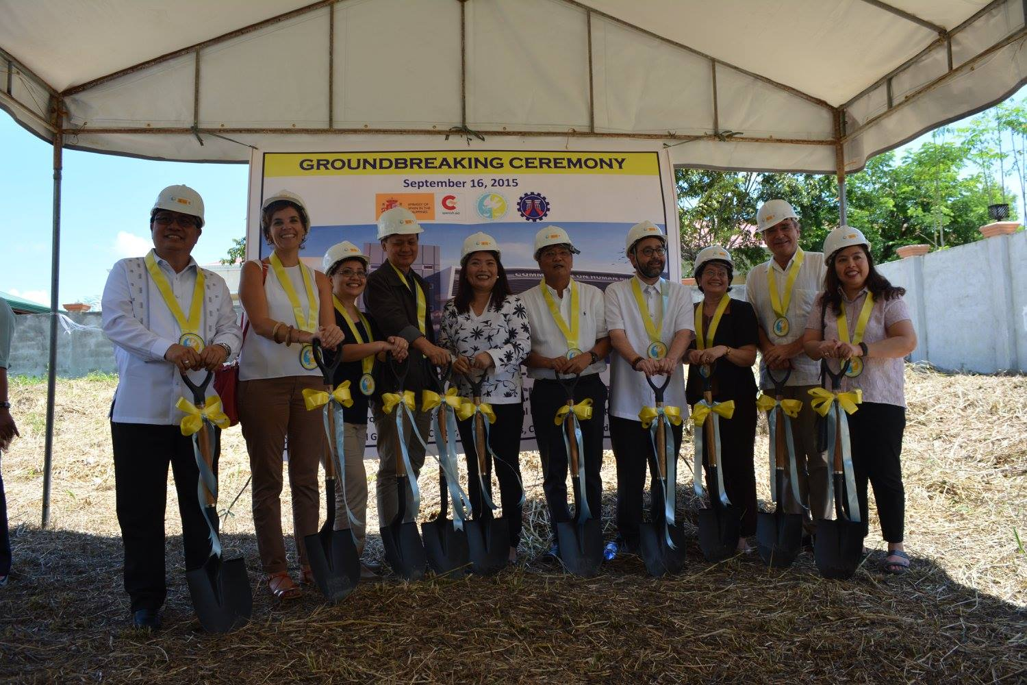

***MOA*** *(CHR & DPWH Region 3 re: Construction)* ***Signing Ceremony:***

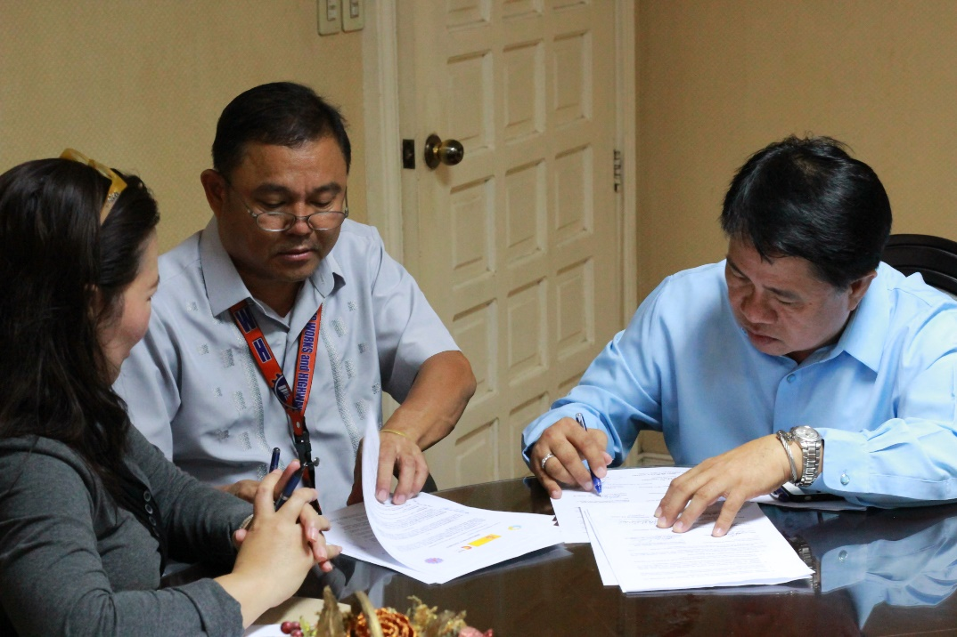

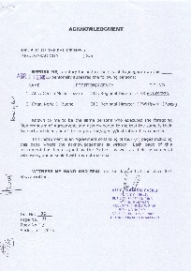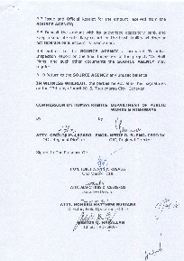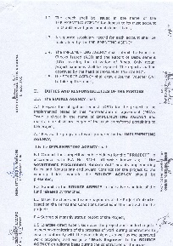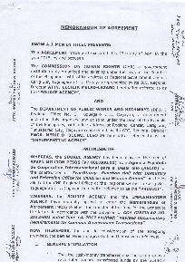

***Deed of Assignment of Rights Over Real Property (between Regional Dev’t. Council & CHR):***

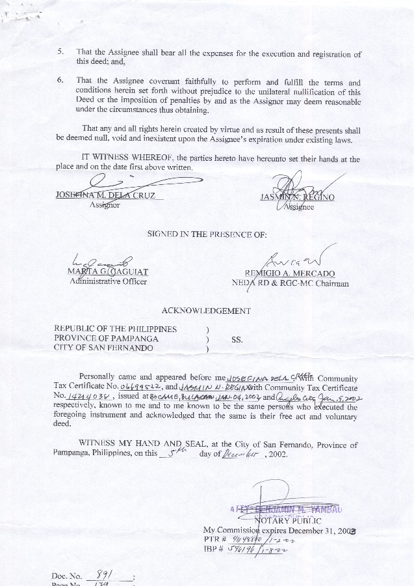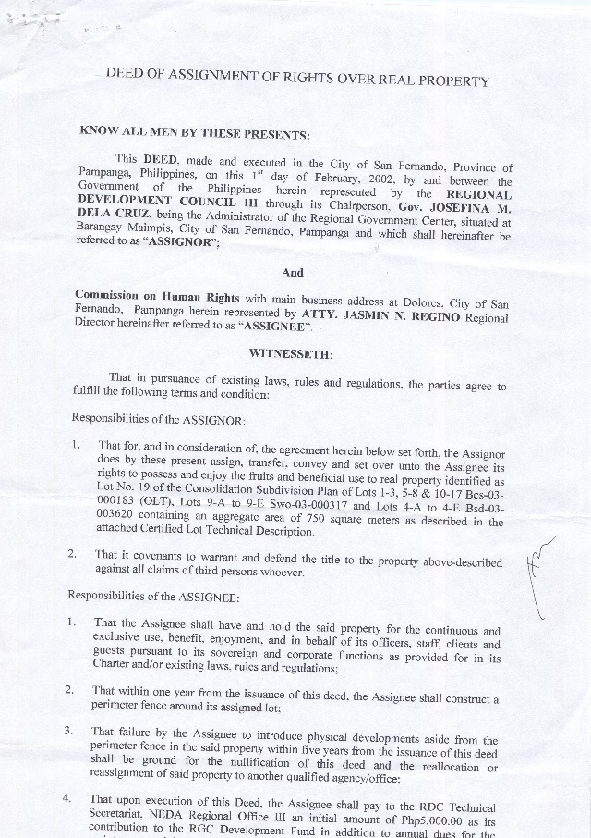

***CHR Region 3 Office BEFORE:*** *3rd Floor, Kehyeng Building*

*Mac Arthur Highway, Dolores*

*City of San Fernando, Pampanga*

